Wilbur Wright College

CIS142 – Introduction to OOP with C++

Midterm Exam

Student:__________________________________________________________

Part # 1 (120 pts):

You have to develop an Application to convert Date entered by the user:

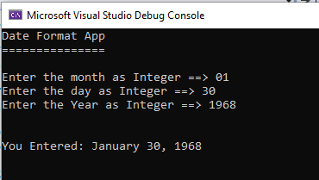

The format for the Month, Day, and Year will be integers… Your Application must Print in the format shown in the output above.

Class Diagram:

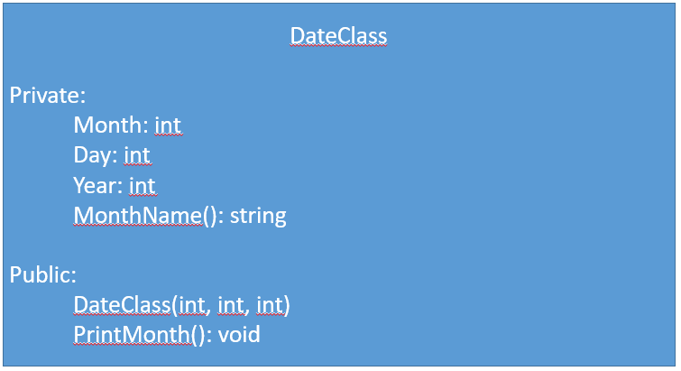

Procedure:

1. Create the Class DateClass with the following objects: 3 integer class variables (Month, Day, Year), and a (1) function call MonthName(). These 4 object will be private.
2. In the public side of the class implement the constructor DateClass(int, int, int). The constructor will have 3 integers as parameters (m-> month, d-> day, y-> year) those 3 parameters must be storage in the class variable Month, Day, and Year. And, the function PrintMonth(). This function won’t return anything, and it won’t accept any parameter. Its only function will be to evaluate the variables: Month, Day, and Year and print it in the format shown in the first graphic. Don’t forget that the PrintMonth() function must invoke the MonthName() function to evaluate the Month variable .
3. The function MonthName() which it will return an string (the month ex: 1=> January, 2= February etc.) You will need to use the IF statement to evaluate the Month passed by the Application when you create the instance of the class
4. Make a screenshot of all your output and code. And Paste them in this MS Word Document.

Part 2 (80 Pts):

1. Develop a program to create the multiplication table of 12 thru 1 (in reverse from 12 to 1). AND you MUST use while loop.
2. Output Sample:

Table of 12 in reverse

==================

12 by 12 🡺 144

12 by 11 🡺 132

12 by 10 🡺 120

12 by 9 🡺 108

12 by 8 🡺 96

12 by 7 🡺 84

12 by 6 🡺 72

12 by 5 🡺 60

12 by 4 🡺 48

12 by 3 🡺 36

12 by 2 🡺 24

12 by 1 🡺 12

….

…..

…..

Table of 1 in reverse

==================

1 by 12 🡺 12

1 by 11 🡺 11

1 by 10 🡺 10

1 by 9 🡺 9

1 by 8 🡺 8

1 by 7 🡺 7

1 by 6 🡺 6

1 by 5 🡺 5

1 by 4 🡺 4

1 by 3 🡺 3

1 by 2 🡺 2

1 by 1 🡺 1

Part 2 OPTIONAL instead of Original Part 2 (40 Pts):

1. Develop a program to create the multiplication table of 5 (in reverse from 12 to 1). AND you MUST use for loop.
2. Output Sample:

5 by 12 = 60

5 by 11= 55

.

.

.

.

5 by 1 = 5